**Lab – 23**

**Student Name: Navneet P**

**Student ID: AF0411619**

***Topic-Some more matplotlib graphs***

Graphs used:

1. **Pie Plot**: A pie plot, also known as a pie chart, is a circular data visualization that is commonly used to represent the distribution of a whole into its constituent parts or categories. It is particularly useful for displaying the proportional composition of a dataset, where each part or category is represented by a "slice" of the pie, and the entire pie represents 100% of the whole.
2. **Scatter plot:** A scatter plot is a data visualization technique that is used to display individual data points on a two-dimensional graph. In a scatter plot, each data point represents one observation or data entry and is plotted as a point on the graph. The position of each point is determined by its values on two variables, typically referred to as the x-axis and y-axis.
3. **Subplots:** a subplot, short for "sub-plot," refers to a feature or capability that allows you to create multiple smaller plots within a single, larger plot or figure. Subplots are commonly used when you want to display multiple graphs or charts side by side, making it easier to compare and analyse different aspects of your data within a single visual representation.

Q1. **Market Share Pie Chart In this example**.

Create a pie chart to illustrate the market share of different smartphone manufacturers in a competitive market. The pie chart will show the proportional distribution of market share among key players.

Solution:

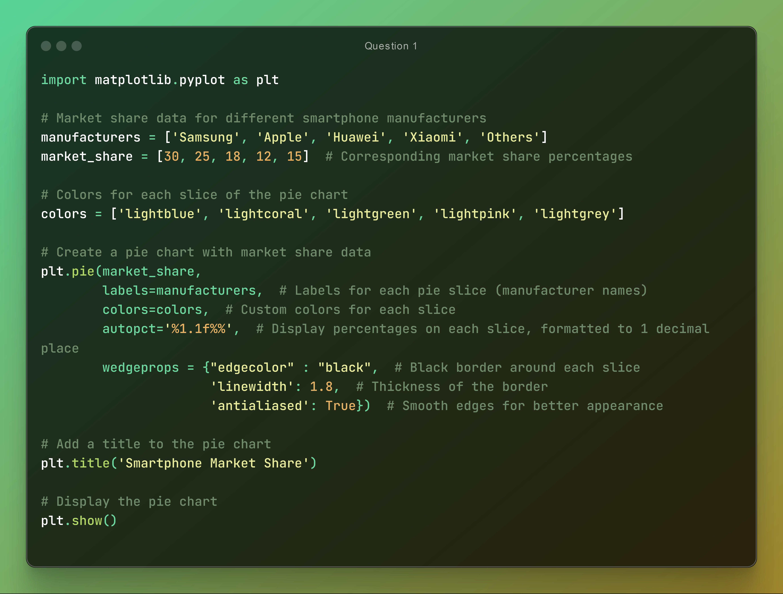

Output:

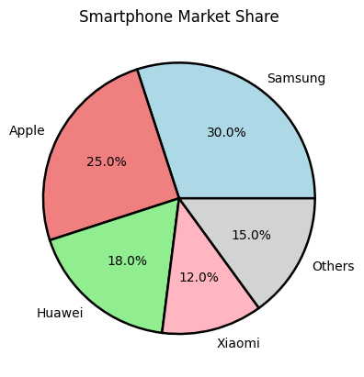

Q2. **Exam Scores vs. Study Hours**

Create a scatter plot to visualize the relationship between the number of study hours and the corresponding exam scores of a group of students.

Solution:

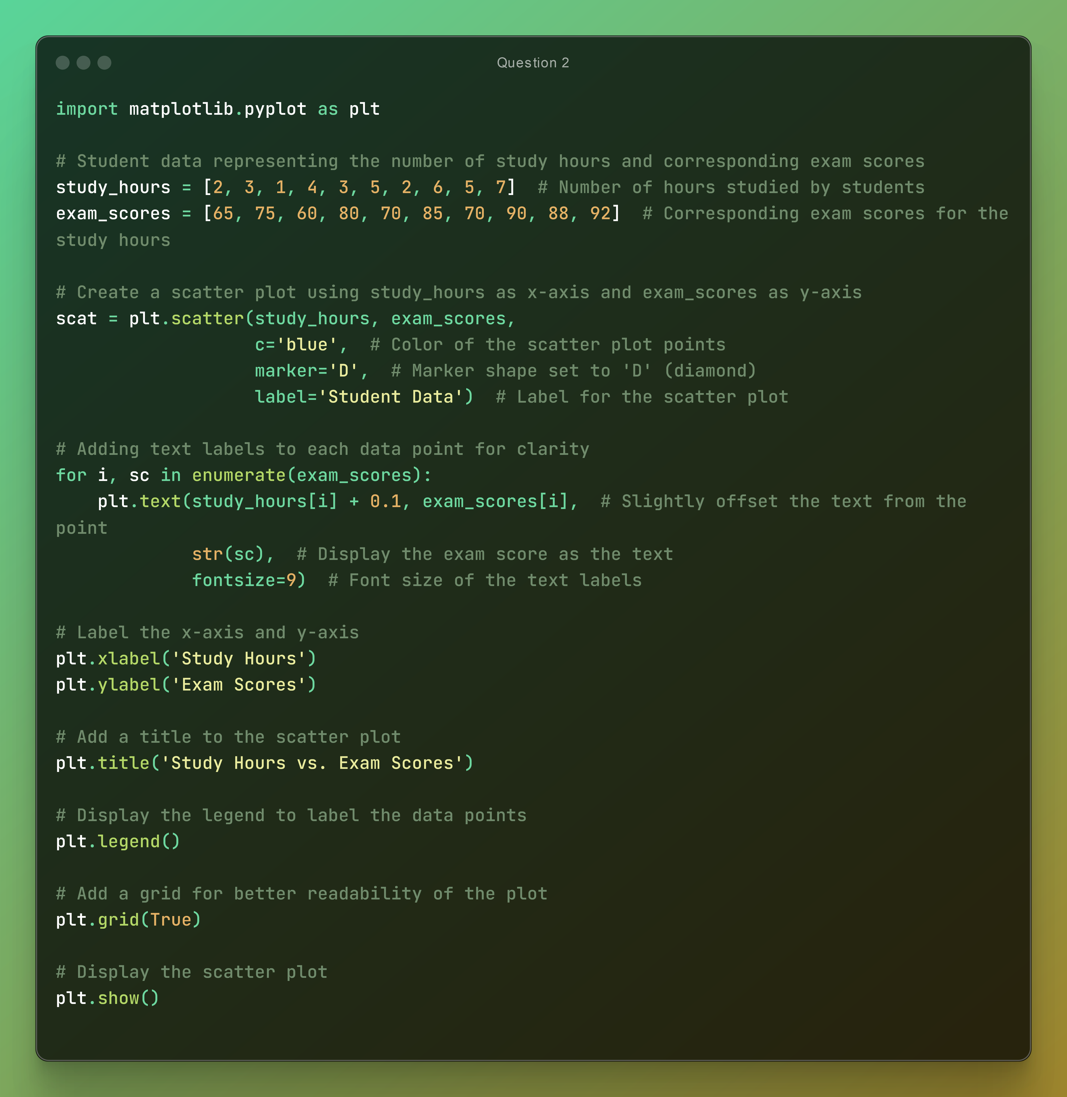

Output:

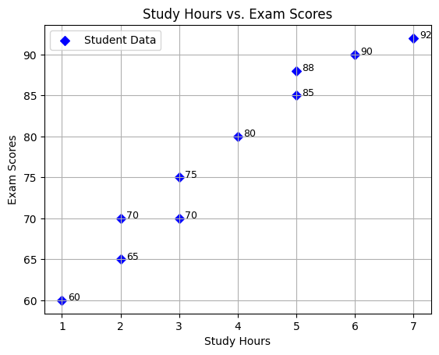

Q3. Using subplot create multiple plots in a single figure.

Solution:



Output:

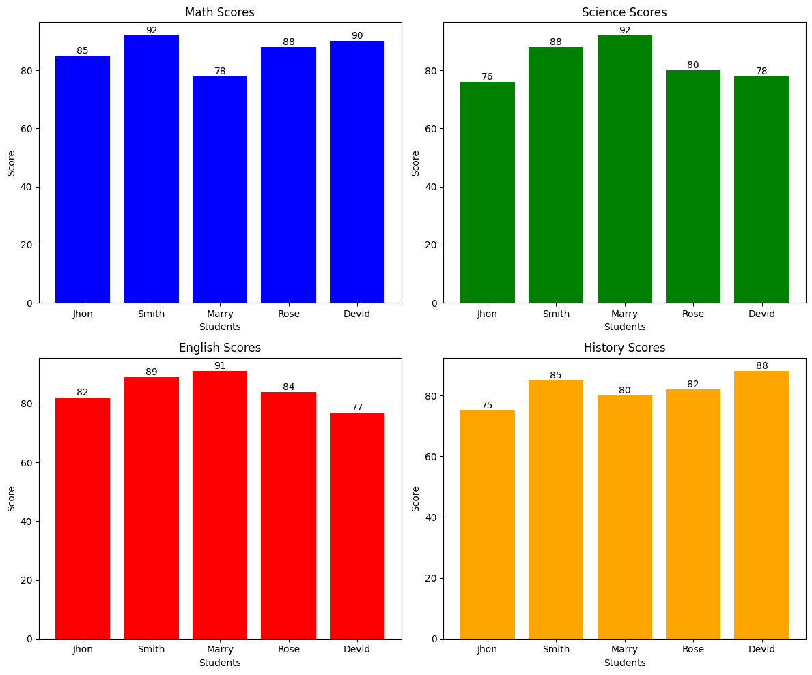

Another subplot example with four line graphs in the same figure.

Solution:



Output:

